Lab – Configuring Rapid PVST+, PortFast, and BPDU Guard

1. Topology

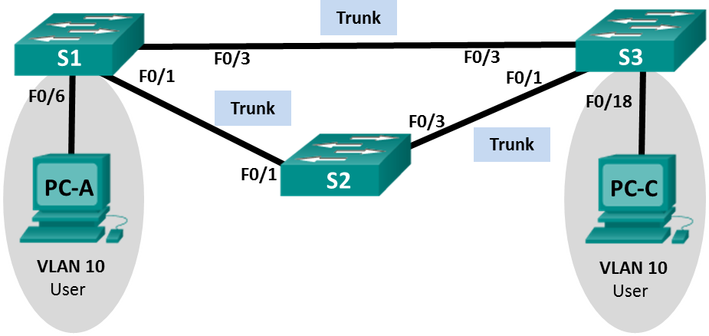

G1/0/24

G1/0/7

G1/0/5

G1/0/5

G1/0/3

G1/0/1

Fa0/3

Fa0/1

S4

S3

S1



VAN PC

Ethernet PC

1. Addressing Table

|  |  |  |  |
| --- | --- | --- | --- |
| Device | Interface | IP Address | Subnet Mask |
| S3 | VLAN 99 | 192.168.1.11 | 255.255.255.0 |
| S1 | VLAN 99 | 192.168.1.12 | 255.255.255.0 |
| S4 | VLAN 99 | 192.168.1.13 | 255.255.255.0 |
| PC-A | NIC | 192.168.0.2 | 255.255.255.0 |
| PC-C | NIC | 192.168.0.3 | 255.255.255.0 |

1. VLAN Assignments

|  |  |
| --- | --- |
| VLAN | Name |
| 10 | User |
| 99 | Management |

Objectives

Part 1: Build the Network and Configure Basic Device Settings

Part 2: Configure VLANs, Native VLAN, and Trunks

Part 3: Configure the Root Bridge and Examine PVST+ Convergence

Part 4: Configure Rapid PVST+, PortFast, BPDU Guard, and Examine Convergence

1. Background / Scenario

The Per-VLAN Spanning Tree (PVST) protocol is Cisco proprietary. Cisco switches default to PVST. Rapid PVST+ (IEEE 802.1w) is an enhanced version of PVST+ and allows for faster spanning-tree calculations and convergence in response to Layer 2 topology changes. Rapid PVST+ defines three port states: discarding, learning, and forwarding, and provides multiple enhancements to optimize network performance.

In this lab, you will configure the primary and secondary root bridge, examine PVST+ convergence, configure Rapid PVST+ and compare its convergence to PVST+. In addition, you will configure edge ports to transition immediately to a forwarding state using PortFast and prevent the edge ports from forwarding BDPUs using BDPU guard.

**Note**: This lab provides minimal assistance with the actual commands necessary for configuration. If necessary, you should refer to previous lab handouts

**Note**: Make sure that the switches have been erased and have no startup configurations

1. Required Resources

* 3 Switches
* 2 Virtual PCs (if on-campus)
* Ethernet cables as shown in the topology

1. Build the Network and Configure Basic Device Settings

In Part 1, you will set up the network topology and configure basic settings, such as the interface IP addresses, device access, and passwords.

* 1. Initialize and reload the switches as necessary.
  2. Verify the network is as shown in the topology.

* 1. Configure PC hosts (if on-campus).
  2. Configure basic settings for each switch.
     1. Disable DNS lookup.

* + 1. Configure the device name as shown in the Topology.







* + 1. Configure **logging synchronous** to prevent console messages from interrupting command entry.



* + 1. Shut down all switch ports.

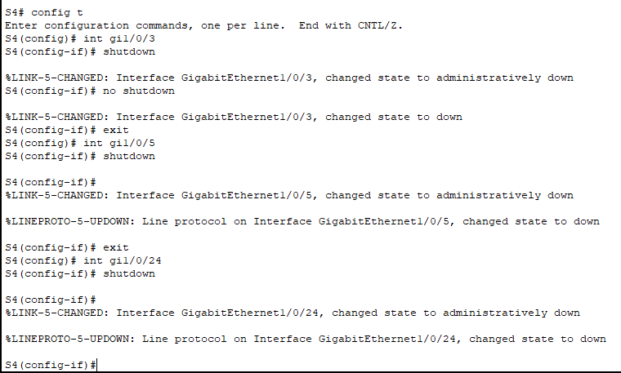

1. Configure VLANs, Native VLAN, and Trunks

In Part 2, you will create VLANs, assign switch ports to VLANs, configure trunk ports, and change the native VLAN for all switches.

* 1. Create VLANs.

Use the appropriate commands to create VLANs 10 and 99 on all of the switches. Name VLAN 10 as **User** and VLAN 99 as **Management**.

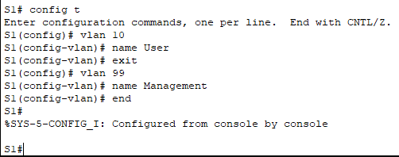

* 1. A white text on a white background

     AI-generated content may be incorrect.Enable user ports in access mode and assign VLANs.

For S3 G1/0/7 and S4 G1/0/24, enable the ports, configure them as access ports, and assign them to VLAN 10.

* 1. Configure trunk ports and assign to native VLAN 99.

Enable ports F0/1 and F0/3 on S1 and configure them as trunk ports.

Enable ports G1/0/1 and G1/0/5 on S3 and configure them as trunk ports.

Enable ports G1/0/3 and Gi1/05 on S4 and configure them as trunk ports.

Assign the trunk port native VLAN to VLAN 99. Example provided below for **G1/0/1** on S3, repeat for all trunked ports

S3(config-if)# **interface g1/0/1**

S3(config-if)# **switchport trunk native vlan 99**

* 1. Configure the management interface on all switches.

Using the Addressing Table, configure the management interface on all switches with the appropriate IP address.

* 1. Verify configurations and connectivity.

Use the **show vlan brief** command on all switches to verify that all VLANs are registered in the VLAN table and that the correct ports are assigned.

Use the **show interfaces trunk** command on all switches to verify trunk interfaces.

Use the **show running-config** command on all switches to verify all other configurations.

What is the default setting for spanning-tree mode on 2960 Cisco switches?

* A screenshot of a computer program

  AI-generated content may be incorrect.The default setting for spanning-tree mode on 2960 Cisco switches is pvst mode

What is the default setting for spanning-tree mode on 3650 Cisco switches?

* The default setting for spanning-tree mode on 3650 Cisco switches is pvst mode

Ping all switches from every other switch. Were the pings successful? => Yes

If your pings were unsuccessful, troubleshoot the configurations until the issue is resolved.

Would PC-A be able to ping PC-C. Yes? No? Why?

* PC-A and PC-C can ping each other because two computers are in the same VLAN.

If on-campus, verify connectivity between PC-A and PC-C. Was your ping successful? ______________

1. Configure the Root Bridge and Examine PVST+ Convergence

In Part 3, you will determine the default root in the network, assign the primary and secondary root, and use the **debug** command to examine convergence of PVST+.

* 1. Determine the current root bridge.

Which command allows a user to determine the spanning-tree status of a Cisco Catalyst switch for all VLANs? Write the command in the space provided.

* Show spanning-tree

Use the command on all three switches to determine the answers to the following questions:

**Note**: There are three instances of the spanning tree on each switch. The default STP configuration on 2960 Cisco switches is PVST+, and on 3650 Cisco switches is Rapid PVST+. Both this STP versions create a separate spanning tree instance for each VLAN (VLAN 1 and any user-configured VLANs).

What is the bridge priority of switch S3 for VLAN 1?

* The bridge priority of switch S3 for VLAN 1 is 32769

What is the bridge priority of switch S1 for VLAN 1?

* The bridge priority of switch S1 for VLAN 1 is 32769

What is the bridge priority of switch S4 for VLAN 1?

* The bridge priority of switch S4 for VLAN 1 is 32769

Which switch is the root bridge?

* The root bridge is Switch4 (S4)

Why was this switch elected as the root bridge?

* This this switch was elected as the root bridge because it has the lowest MAC address.
  1. Configure a primary and secondary root bridge for all existing VLANs.

Having a root bridge (switch) elected by MAC address may lead to a suboptimal configuration. In this lab, you will configure switch S1 as the root bridge and S3 as the secondary root bridge.

* + 1. Configure switch S1 to be the primary root bridge for all existing VLANs.

S1(config)# **spanning-tree vlan 1,10,99 root primary**

* + 1. Configure switch S3 to be the secondary root bridge for all existing VLANs.

S3(config)# **spanning-tree vlan 1,10,99 root secondary**

Use the **show spanning-tree** command to answer the following questions:

What is the bridge priority of S3 for VLAN 1?

=> The bridge priority of S3 for VLAN 1 is 20481

What is the bridge priority of S1 for VLAN 1?

=> The bridge priority of S1 for VLAN 1 is 24577

Which interface in the network is in a blocking state?

=> The interfaces in the network in the blocking state are the GigabitEthernet1/0/5 and GigabitEthernet1/0/7

How might you configure S3 to be the primary root bridge for VLAN 10 while S1 is the primary root bridge for all remaining VLANs?

=> S3(config)# **spanning-tree vlan 10 root primary**

=> S1(config)# **spanning-tree vlan 1,99 root primary**

* 1. Change the Layer 2 topology and examine convergence.

Change STP mode to PVST+ on S3

S3(config)#**spanning-tree mode pvst**

Change STP mode to PVST+ on S4

S4(config)#**spanning-tree mode pvst**

**Note:** PVST+ and Rapid PVST+ are compatible, however, we are changing S3 and S4 to run PVST+ to observe PVST+ convergence logs.

To examine PVST+ convergence, you will create a Layer 2 topology change while using the **debug** command to monitor spanning-tree events.

* + 1. Enter the **debug spanning-tree events** command in privileged EXEC mode on switch S4.

S4# **debug spanning-tree events**

Spanning Tree event debugging is on

* + 1. Create a topology change by disabling interface G1/0/3 on S4.

S4(config)# **interface g1/0/3**

S4(config-if)# **shutdown**

*Oct 14 16:23:33.878: STP: VLAN0001 new root port Gi1/0/5, cost 23

*Oct 14 16:23:33.879: STP: VLAN0001 Gi1/0/5 -> listening

*Oct 14 16:23:33.879: STP[1]: Generating TC trap for port GigabitEthernet1/0/3

*Oct 14 16:23:33.879: STP: VLAN0010 new root port Gi1/0/5, cost 23

*Oct 14 16:23:33.879: STP: VLAN0010 Gi1/0/5 -> listening

*Oct 14 16:23:33.879: STP[10]: Generating TC trap for port GigabitEthernet1/0/3

*Oct 14 16:23:33.880: STP: VLAN0099 new root port Gi1/0/5, cost 23

*Oct 14 16:23:33.880: STP: VLAN0099 Gi1/0/5 -> listening

*Oct 14 16:23:33.880: STP[99]: Generating TC trap for port GigabitEthernet1/0/3

*Oct 14 16:23:35.868: %LINK-5-CHANGED: Interface GigabitEthernet1/0/3, changed state to administratively down

*Oct 14 16:23:35.872: %LINK-3-UPDOWN: Interface Vlan1, changed state to down

*Oct 14 16:23:35.879: STP: VLAN0001 sent Topology Change Notice on Gi1/0/5

*Oct 14 16:23:35.879: STP: VLAN0010 sent Topology Change Notice on Gi1/0/5

*Oct 14 16:23:35.880: STP: VLAN0099 sent Topology Change Notice on Gi1/0/5

*Oct 14 16:23:36.871: %LINEPROTO-5-UPDOWN: Line protocol on Interface GigabitEthernet1/0/3, changed state to down

*Oct 14 16:23:36.872: %LINEPROTO-5-UPDOWN: Line protocol on Interface Vlan1, changed state to down

*Oct 14 16:23:48.879: STP: VLAN0001 Gi1/0/5 -> learning

*Oct 14 16:23:48.880: STP: VLAN0010 Gi1/0/5 -> learning

*Oct 14 16:23:48.880: STP: VLAN0099 Gi1/0/5 -> learning

*Oct 14 16:24:03.880: STP[1]: Generating TC trap for port GigabitEthernet1/0/5

*Oct 14 16:24:03.880: STP: VLAN0001 Gi1/0/5 -> forwarding

*Oct 14 16:24:03.881: STP[10]: Generating TC trap for port GigabitEthernet1/0/5

*Oct 14 16:24:03.881: STP: VLAN0010 Gi1/0/5 -> forwarding

*Oct 14 16:24:03.881: STP[99]: Generating TC trap for port GigabitEthernet1/0/5

*Oct 14 16:24:03.882: STP: VLAN0099 Gi1/0/5 -> forwarding

*Oct 14 16:24:05.884: %LINK-3-UPDOWN: Interface Vlan1, changed state to up

*Oct 14 16:24:06.884: %LINEPROTO-5-UPDOWN: Line protocol on Interface Vlan1, changed state to up

**Note**: Before proceeding, use the **debug** output to verify that all VLANs on G1/0/5 have reached a forwarding state then use the command **no debug spanning-tree events** to stop the **debug** output.

Through which port states do each VLAN on F0/3 proceed during network convergence?

=> Port states do each VLAN on F0/3 proceed during network convergence are **Listening->Learning->Forwarding**

Using the time stamp from the first and last STP debug message, calculate the time (to the nearest second) that it took for the network to converge. **Hint**: The debug timestamp format is date hh.mm.ss:msec.

=> The time it took for the network to converge is 4 milliseconds

1. Configure Rapid PVST+, PortFast, BPDU Guard, and Examine Convergence

In Part 4, you will configure Rapid PVST+ on all switches. You will configure PortFast and BPDU guard on all access ports, and then use the **debug** command to examine Rapid PVST+ convergence.

* 1. Configure Rapid PVST+.
     1. Configure S3 for Rapid PVST+.

S3(config)# **spanning-tree mode rapid-pvst**

* + 1. Configure S1 and S4 for Rapid PVST+.

* + 1. Verify configurations with the **show running-config | include spanning-tree mode** command. The example below is for switch S3, repeat for all three switches

S3# **show running-config | include spanning-tree mode**

spanning-tree mode rapid-pvst

* 1. Configure PortFast and BPDU Guard on access ports.

PortFast is a feature of spanning tree that transitions a port immediately to a forwarding state as soon as it is turned on. This is useful in connecting hosts so that they can start communicating on the VLAN instantly, rather than waiting on spanning tree. To prevent ports that are configured with PortFast from forwarding BPDUs, which could change the spanning tree topology, BPDU guard can be enabled. At the receipt of a BPDU, BPDU guard disables a port configured with PortFast.

* + 1. Configure interface G1/0/7 on S3 with PortFast.

S3(config)# **interface G1/0/7**

S3(config-if)# **spanning-tree portfast**

* + 1. Configure interface G1/0/7 on S3 with BPDU guard.

S3(config)# **interface G1/0/7**

S3(config-if)# **spanning-tree bpduguard enable**

* + 1. Globally configure all non-trunking ports on switch S4 with PortFast. Write the command in the space provided.

=> int gi1/0/24

=> spanning-tree portfast

* + 1. Globally configure all non-trunking PortFast ports on switch S4 with BPDU guard. Write the command in the space provided.

=> int gi1/0/24

=> spanning-tree bpduguard enable

* 1. Examine Rapid PVST+ convergence.
     1. Enter the **debug spanning-tree events** command in privileged EXEC mode on switch S4.

* + 1. Create a topology change by enabling interface G1/0/3 on switch S4.

S4(config)# **interface g1/0/3**

S4(config-if)# **no shutdown**

*Oct 14 16:33:01.730: %LINK-3-UPDOWN: Interface GigabitEthernet1/0/3, changed state to up

*Oct 14 16:33:04.568: RSTP(1): initializing port Gi1/0/3

*Oct 14 16:33:04.568: RSTP(1): Gi1/0/3 is now designated

*Oct 14 16:33:04.569: RSTP(10): initializing port Gi1/0/3

*Oct 14 16:33:04.569: RSTP(10): Gi1/0/3 is now designated

*Oct 14 16:33:04.569: RSTP(99): initializing port Gi1/0/3

*Oct 14 16:33:04.569: RSTP(99): Gi1/0/3 is now designated

*Oct 14 16:33:04.573: RSTP(1): transmitting a proposal on Gi1/0/3

*Oct 14 16:33:04.573: RSTP(10): transmitting a proposal on Gi1/0/3

*Oct 14 16:33:04.574: RSTP(99): transmitting a proposal on Gi1/0/3

*Oct 14 16:33:06.299: RSTP(1): updt roles, received superior bpdu on Gi1/0/3

*Oct 14 16:33:06.299: RSTP(1): Gi1/0/3 is now root port

*Oct 14 16:33:06.299: RSTP(1): Gi1/0/5 blocked by re-root

*Oct 14 16:33:06.299: RSTP(1): synced Gi1/0/3

*Oct 14 16:33:06.299: RSTP(1): Gi1/0/5 is now alternate

*Oct 14 16:33:06.300: RSTP(10): updt roles, received superior bpdu on Gi1/0/3

*Oct 14 16:33:06.300: RSTP(10): Gi1/0/3 is now root port

*Oct 14 16:33:06.300: RSTP(10): Gi1/0/5 blocked by re-root

*Oct 14 16:33:06.300: RSTP(10): synced Gi1/0/3

*Oct 14 16:33:06.301: RSTP(10): Gi1/0/5 is now alternate

*Oct 14 16:33:06.301: RSTP(99): updt roles, received superior bpdu on Gi1/0/3

*Oct 14 16:33:06.301: RSTP(99): Gi1/0/3 is now root port

*Oct 14 16:33:06.301: RSTP(99): Gi1/0/5 blocked by re-root

*Oct 14 16:33:06.301: RSTP(99): synced Gi1/0/3

*Oct 14 16:33:06.301: RSTP(99): Gi1/0/5 is now alternate

*Oct 14 16:33:06.310: STP[1]: Generating TC trap for port GigabitEthernet1/0/3

*Oct 14 16:33:06.311: STP[10]: Generating TC trap for port GigabitEthernet1/0/3

*Oct 14 16:33:06.311: STP[99]: Generating TC trap for port GigabitEthernet1/0/3

*Oct 14 16:33:06.325: RSTP(1): transmitting an agreement on Gi1/0/3 as a response to a proposal

*Oct 14 16:33:06.325: RSTP(10): transmitting an agreement on Gi1/0/3 as a response to a proposal

*Oct 14 16:33:06.326: RSTP(99): transmitting an agreement on Gi1/0/3 as a response to a proposal

Using the time stamp from the first and last RSTP debug message, calculate the time that it took for the network to converge.

=> The time that it took for the network to converge is 1,758 milliseconds.

1. Reflection
   1. What is the main benefit of using Rapid PVST+?

* The benefit of using Rapid PVST+ is Per-VLAN load balancing and optimized traffic flow.
  1. How does configuring a port with PortFast allow for faster convergence?
* Configure a port with PortFast allow for faster convergence by forwarding mode instead of listening, which decreases Layer 2 convergence time.
  1. What protection does BPDU guard provide?
* BPDU Guard provides protect the port from receiving STP BPDUs